Macroinvertebrate image analysis system
Implementation summary

1. Executive summary
A practical data-analysis workflow was completed to gain insight into the system. First, the folders holding images were scanned and added to the structured Pandas DataFrame. The file path, file name, class label, and width and height of the image were recorded for each image by the program. There are 2,665 images from 17 classes in the dataset. The summary table included an average image width of 599.27 pixels, and an average image height of 389.98 pixels. This indexing step was crucial as it enabled the dataset to be verified prior to model training and proved that the program was processing the real image folders and not a set of predetermined or manually-created images.
Several output were obtained from the exploratory data analysis stage, which is to understand the dataset. The class distribution chart revealed some classes with considerably higher number of images than others particularly Gammarus sp, and some classes with relatively few images. This implies that for this model the large classes may be learned more effectively than the smaller ones. The width and height distribution charts of the image revealed that the majority of images had a width of approximately 600 pixels and the majority of image heights were grouped around the values of 338 pixels and 450 pixels. A sample image grid was also created to visually compare various types of macroinvertebrates. These outputs have been saved in the outputs/eda folder as PNG files.
The image classification stage was done using OpenCV to prepare images for machine learning. All images were loaded, converted to grayscale, resized to a fixed size, normalized to the range [0,1] and flattened to a numerical feature vector. The data set was divided into 80% training data and 20% test data. The Random Forest classifier was chosen from the Scikit-learn library because the data was structured feature data, the model was easy to explain, and it was an appropriate first working image classifiers. The accuracy of the trained model in the test set was about 68.48%. A classification report, confusion matrix were stored in the output/reports folder and a trained model was stored in the output/models folder using joblib.
An application deployment stage was completed with the help of a console menu. The menu provided the user with the option to display the classification report, the EDA output files, predict a sample image, test invalid input and exit the application. This interface was used to connect with the real data set and store the output, and also trained the model, and thus not a demo. All the menu options were tested manually and found correct. The user tested options 1, 2, 3, 4, 9 and 5, which correspond to the following events: dataset summary, EDA outputs, classification report, image prediction, invalid menu choice, and application exit.
The project was performed using the Python packages for clear purposes. Pathlib was used to handle file paths, Pandas for metadata, NumPy for numerical arrays, OpenCV for images, Matplotlib for charts, Scikit-learn for training and evaluating the model, PIL for images, and joblib for saving the trained model. Overall it fulfils the primary assessment criteria in the main and produced evidence of EDA, trained a predictive model, saved the outputs, and documented testing evidence.
2. Class and module overview
The system was designed by writing the different pieces of code in Google Colab. The same logic can be grouped into the following modules to demonstrate how the logic is organised for the final submission according to the object-oriented structure required by the assessment.

Class/module | Role in the system
DatasetIndexer | Scans image folders and stores file paths, class labels, widths and heights in a DataFrame.
EDAService | Generates the class distribution chart, image size charts, sample image grid and summary table.
ImagePreprocessor | Loads each image, converts it to grayscale, resizes it and normalises pixel values.
ClassifierService | Trains the Random Forest model, evaluates results and saves the trained model using joblib.
WorkflowService | Coordinates dataset loading, EDA generation, model training and prediction.
ConsoleApp | Provides the text-based user menu connected to the real dataset, reports and saved model.
3. Testing summary
The manual testing was done by operating the console application and verifying the value of each option with the expected value. Test evidence demonstrates the ability of the system to display the summary, display the EDA outputs, load the reports, predict the image and exit with an invalid input correctly.

Test input | Purpose | Actual result | Status
1 | Show dataset summary | Summary displayed correctly | Passed
2 | Show EDA output files | EDA file names and charts displayed | Passed
3 | Show classification report | Accuracy and classification metrics displayed | Passed
4 | Predict sample image | Predicted class displayed with image | Passed
9 | Check invalid menu choice | Invalid choice message displayed | Passed
5 | Exit application | Application exited successfully | Passed

4. Screenshots and sample outputs
The following screenshots provide evidence that the project was run successfully in Google Colab and that the required outputs were generated.
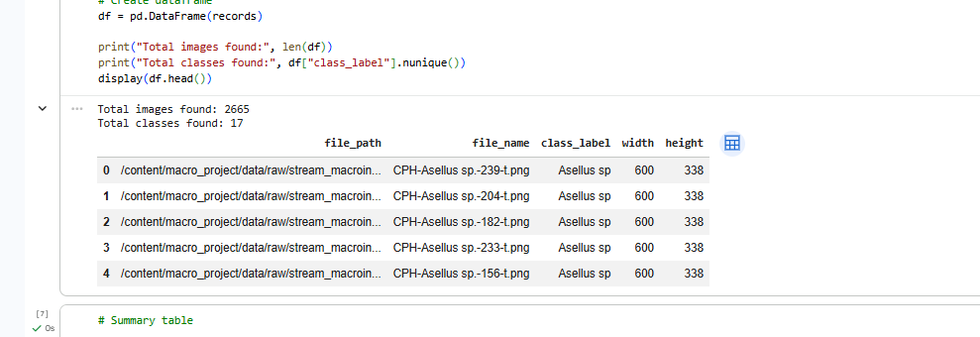
Figure 1. Dataset indexing output showing 2,665 images and 17 classes.
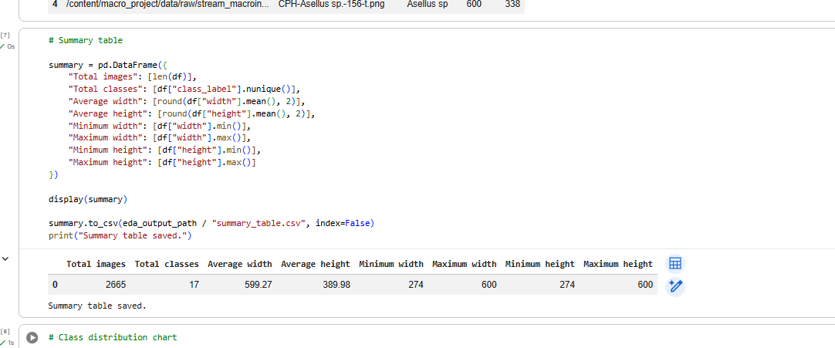
Figure 2. Summary table showing image count, class count and image dimensions.
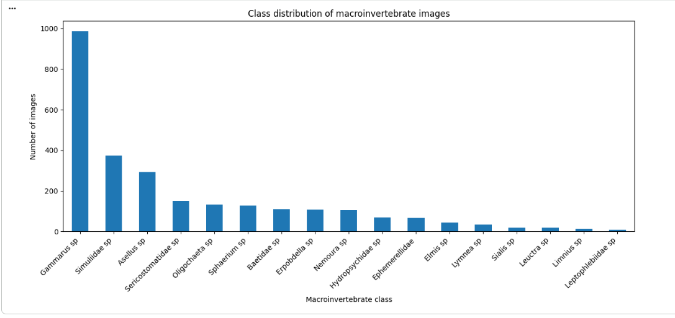
Figure 3. Class distribution chart for macroinvertebrate images.
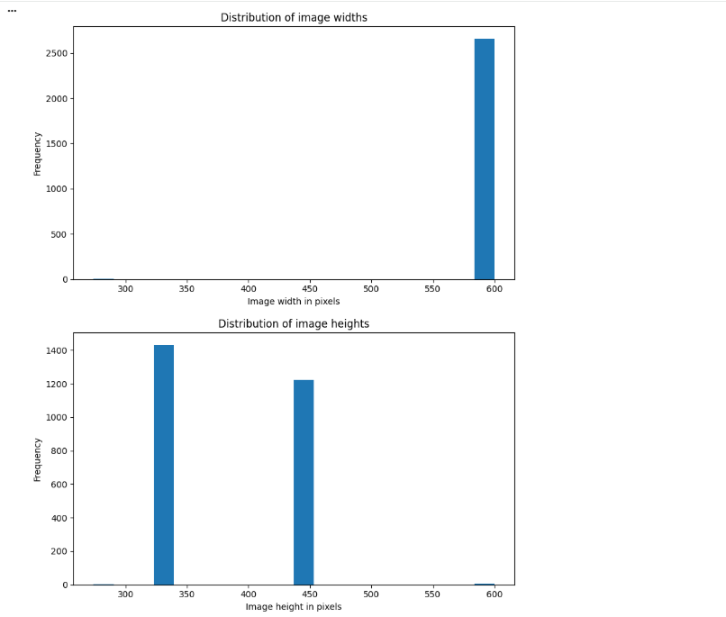
Figure 4. Image width and height distribution charts.
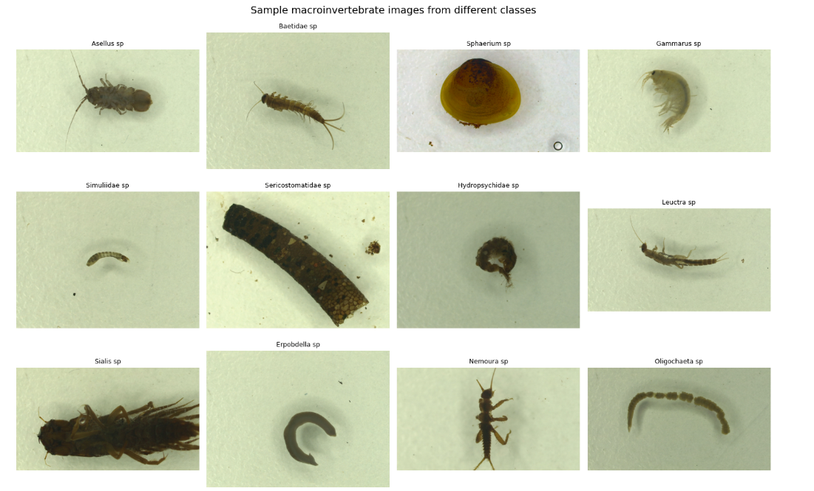
Figure 5. Sample image grid from different macroinvertebrate classes.
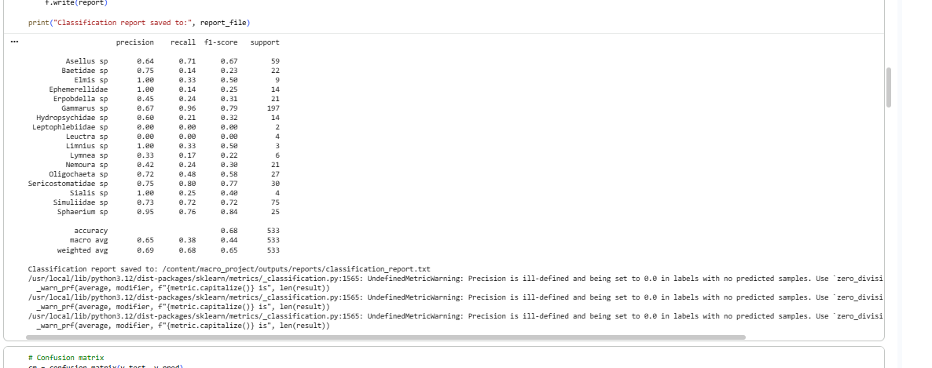
Figure 6. Classification report generated by the Random Forest model.
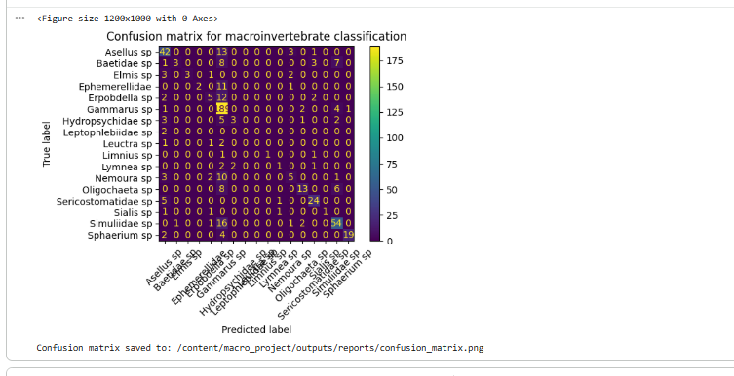
Figure 7. Confusion matrix for macroinvertebrate classification.
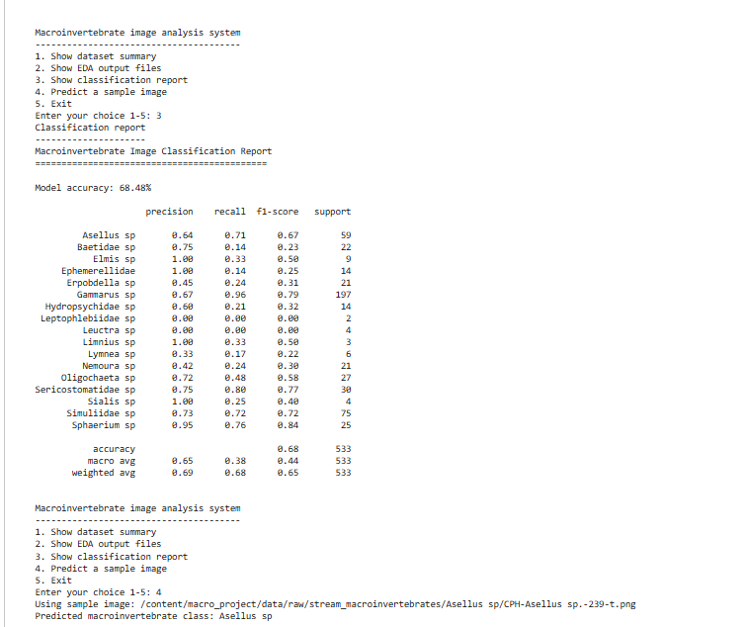
Figure 8. Console application displaying the classification report and prediction workflow.
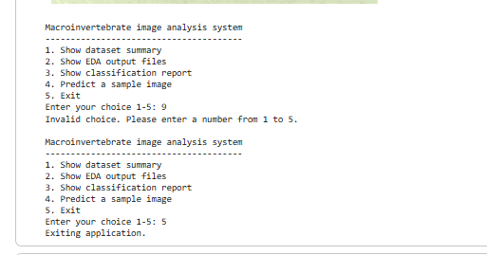
Figure 9. Manual testing evidence showing invalid choice and exit function.
5. Work division and acknowledgement
5. Work division and acknowledgement
To ensure that the project work was clearly completed both technically and with respect to the documentation requirements, the work was split between two members of the group. The data set preparation, exploratory data analysis and output generating were mainly carried out by student 1. This included downloading and organising the Stream Macroinvertebrates dataset, checking that the image folders were correctly extracted, creating the dataset summary table, generating the class distribution chart, image width and height distribution charts, and sample image grid. Student 1 also assisted in the review of EDA results and gave explanations on the impact the characteristics of the dataset had on the subsequent classification stage (class imbalance and image size variation).
Preprocessing of images, development of models, testing of applications and documentation were the primary task of student 2. This involved grayscaling images, resizing images, normalizing pixel values, creating train-test split, training the Random Forest Classifier, creating classification report and confusion matrix, and saving the trained model by joblib. Student 2 also prepared the implementation summary, created the README file and did the manual testing of the menu options, while developing console menu app.
Both students reviewed the final system, ensuring that the console application was linked to the real data set, EDA outputs, classification report and saved model. Both members also spoke about the inherent problems with the model and potential future enhancements including the incorporation of colour or data augmentation or a convolutional neural network for improved accuracy of image classification.
The code snippets for the image preprocessing, train-test splitting, random forest training, report on the classification results, and confusion matrix were borrowed from the unit learning materials and standard python machine learning examples. The ideas were changed and implemented for the Stream Macroinvertebrates data set for the assignment purposes. This is an acknowledgment added as the implementation summary should be informative about the division of work and reuse or modification of code.

